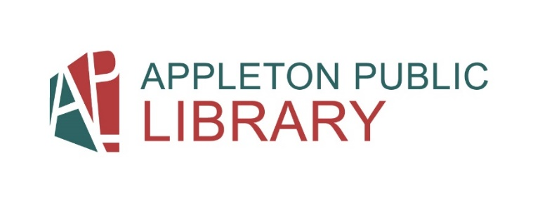

Materials Management Department:
Children’s Shelving Volunteer Position Description
Supervisors: Bethany Neuman (bneuman@apl.org)
Volunteer Coordinator: Colleen Holz (cholz@apl.org)
Location: Appleton Public Library at 200 N. Appleton St.
Information and Nature of Work: After assigned area training: shelve library items, shelf-read (checking order), and tidy materials on shelves.
Essential Job Functions:
- Put recently returned library materials in correct order on the appropriate collection shelves.
- Shelf-Reading assigned collection.
- Tidy entire shelves via edging and tightening bookends in assigned collection.
- Placing recently returned items in order on the appropriate carts to prepare for shelving.

Skills/Qualifications:
- Must demonstrate proficiency alphabetizing and ability to learn Dewey Decimal ordering.
- An ability to accurately sort and arrange materials alphabetically and numerically according to Appleton Public Library Shelving rules and standards.
- An ability to understand and effectively carry out oral and written instructions.
- An ability to read fine print, to reach high and low shelves, bend over, and to push a loaded cart over carpeting (up to 300 lbs.) on various floor surfaces.
- An ability to stand or walk for an entire shift.
- Must be able to answer patron’s general questions about directions within the library.
- Tactful and courteous communication skills.
- An ability to learn new technology.
- An ability to adapt to change.

Training: Approximately 3 hours(s)
Shift requirement: Be able to commit to 2-hour shifts via sign-up calendar. If illness or schedule conflicts arise, please contact Bethany and Colleen as soon as possible.

Last Update: December 2024

