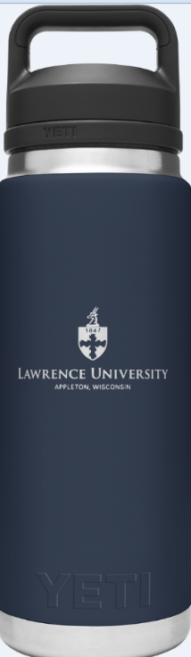
Lawrence University
YETI Water Bottle
Specifications:
- Color – Navy
- Size – 26 oz
- Cost - $34.00
To Order: Send the completed for to Human Resources via:
- Email at humanresources@lawrence.edu
- Campus Mail

Name: | LU ID:
Department/Office:
Payment Method: Payroll Deduction Cash or Check Enclosed
Signature:
Following receipt of your order, the Human Resources Office will contact you regarding pick-up or delivery of your water bottle.

